November 16th, 2018

Greetings Dr. Roysam,

We want to thank you again for approving our Makerspace and senior design project, Knuckles, the assistive robotic arm to be exhibited at the 2019 ECEDHA Conference in Tucson, Arizona.

We have finished constructing the robot arm and are now trying to control the motors using Arduino and Rviz. We were having a significant amount of difficulty using an object detection program working with ROS as we had originally planned, so we have decided to simplify that aspect of the project and are using AprilTags instead. AprilTags are basically QR codes that can be scanned by the RealSense camera, and clearly mark an object we want it to recognize. In addition, multiple of these tags can be visualized in Rviz with respect to the robot arm at the same time. In retrospect, we should have started with AprilTags initially, and then moved to an object detection program from there. The project as originally described required us to learn Linux, ROS, computer vision, machine learning, and robotics in general. The AprilTags allow us to focus on Linux and ROS, and allows us to build a solid foundation before moving to machine learning. We still plan to use an object detection program as originally planned, but want to have a fully working prototype to demonstrate first.

We are still discussing some current needs such as the Intel Voice Enabling Development Kit and a PC. But as they are required at later dates, we are going to seek company sponsorship to lower the overall cost to the department.

Thank you for your continued support of our research. If you have any questions or concerns, feel free to contact us.

Sincerely,

Matthew van Zuilekom

Andrew Blanchard

Rym Benchaabane

Paola Hernandez

# 

# Knuckles, Assistive Robotic Arm

# Sponsored by Makerspace

# Fall 2018

# ADDIE Progress (II) Report

# Matthew van Zuilekom

# 

# Team members:

# Andrew Blanchard, Paola Hernandez, Rym Benchaabane

# 

**Purpose**

Knuckles is an assistive robotic arm that will hand the user requested objects and tools through voice command. It will serve as a convenient assistant that will increase the user’s productivity and decrease the risk of dexterity incidents.

**Overview Diagram and Background**

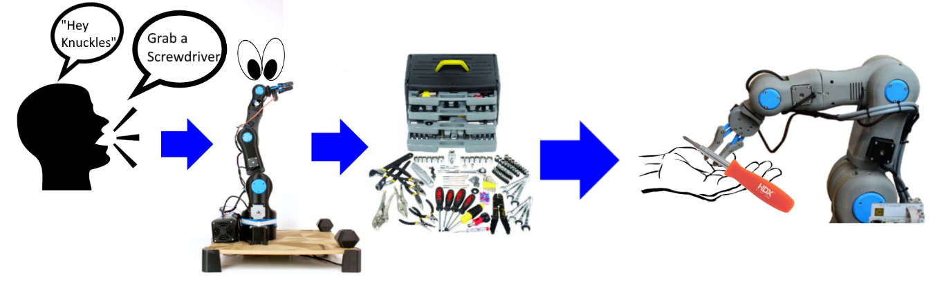

**Figure 1. Overview diagram of Knuckles functionalities**

Knuckles will be able to respond to voice commands and retrieve requested objects for the user. To accomplish this, we will connect a microphone to a RaspBerry Pi3+ which will start listening for a voice command once the user has said “Hey, Knuckles!” Voice commands will be converted to text using the Amazon Alexa Voice Service, to be interpreted by ROS on a main computer, which the RaspBerry Pi3+ is also connected. From there, the main computer will connect to an Arduino MEGA & RAMPS 1.4 combination, which is connected to the motors used to control the arm. An Intel RealSense camera will be attached to the gripper of the robot arm, which will be used to locate the requested object. An AprilTag will on each requestable object, which is what the camera will be looking for.

In today’s society, people are rushed and tend to multitask. According to research from the scientific journal, *Current Biology[1]*, shifting focus and attempting to multitask reduces productivity by around 40%. *SMF Mutual Insurance* adds that multitasking can lead to dexterity incidents while performing hands-on work.[2]

The problem is that multitasking causes a lack of focus on a task which results to a waste time, money, and can also lead to serious injury. What is needed is a solution that allows the user to continue with their task without distractions, and can assist the user as needed. The extra hand will allow one to focus on the work without having to get up and grab another tool, which saves one time and effort in completing the current task. Figure 1 represents Knuckles’ ability to respond to voice commands and hand the requested object to the user.

**Deliverables**

During the Fall semester, our team almost completed the **hardware part of the project**, which is the **physical robotic arm and gripper** with the additional hardware used for object localization (**Intel RealSense camera**, omnidirectional mic, **tactile pads**). The user will be able to use a developed simulation on the computer to manually control the robot through text commands. **Simulation will be executed using Rviz**, and text commands, object recognition, manual control of arm and gripper will be planned and completed at the end of the semester.

At the end of the Spring semester, our team will provide the software portion of Knuckles, which will include the object detection and voice recognition portion of the project. With the additional help of the software packages, the user will be able to give voice commands to receive requested objects from Knuckles.

**Target Objectives and Goal Analysis**

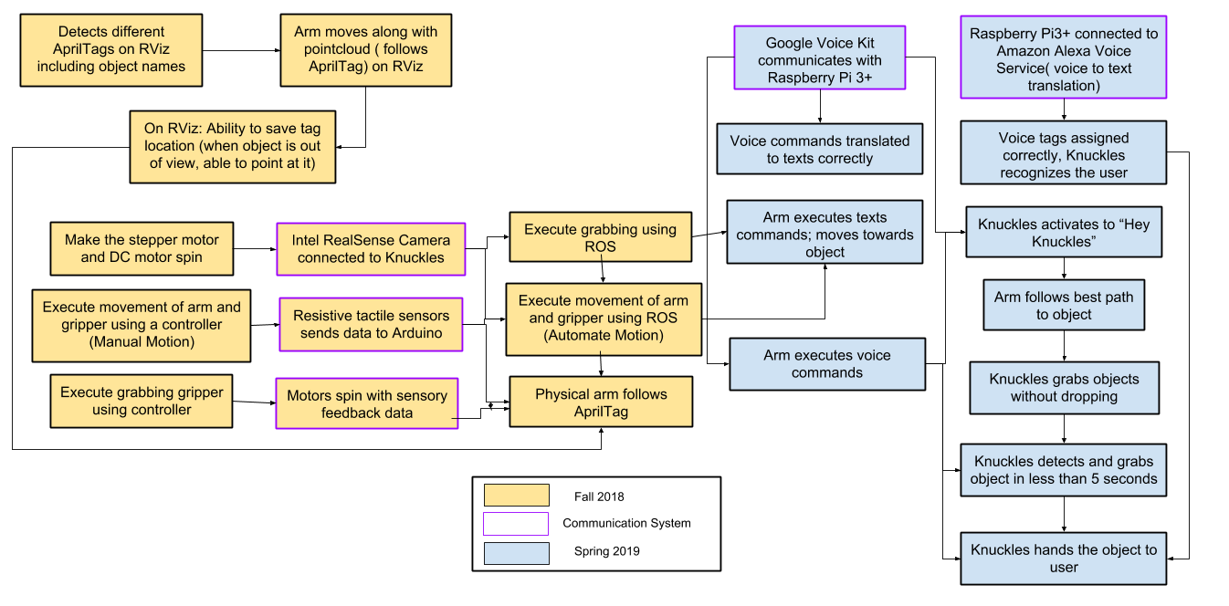

**Figure 2. The testing and goals diagram**

**Summary of Activities**

|  |  |  |  |  |
| --- | --- | --- | --- | --- |
| **Goal Status** | **Goal Description** | **Goal Modifications** | **Test Plan** | **Issues** |
| **In Progress** | This will allow us to confirm the arm is moving correctly and freely, before applying software to it. The mechanical properties of Knuckles are divided into two components, the arm and the gripper. The arm’s 5-axis movement and mechanics will be developed using ROS on Linux Ubuntu 16.04 LTS. We are connecting the arm’s joints with a total of 6 stepper motors (2 for the base). These motors will be processed by ROS and controlled by Arduino. The Arduino has a add-on motor shield RAMPS1.4V. The TB6560 is the motor driver that is going to be directly wired to the motors and RAMPS1.4V. The RAMPS1.4V is powered by a 24V to 12V converter and this converter is connected to a 24V power supply. We will have a breadboard as a center of power connections. | None | **Test the mobility of the robot:** Verify the arm and gripper motion with a controller. This arm uses seven motors: six to control the movement of the arm, and one to control the gripper. The controller will be able to control each of these motors individually by changing the polarity and magnitude of the voltage across each of the motors. Two of the six motors used to control the arm will control the same movement at the base of the gripper, so the controller will have to control those two motors at the same time as well | We had a significant delay ordering the necessary parts as we were doing it through Makerspace, which caused the construction of the arm to be delayed. We are currently in the process of controlling the motors using the arduino firmware. |
| **In progress** | The goal is to have the arm properly communicating with ROS, and be able to control the entire arm using this software. | None | **Test robot connection to ROS:** Request the robot to position itself in straight up, straight out,  and in reaching motions. The test will be successful if these basic movements are shown in both the simulation and the physical arm. | Again, we had a delay in building the physical robot arm, so this was delayed as well. |
| **Completed** | This is a major part of the project. Rviz is able to visualize as many tags as we can fit in the camera view, and is able to remember the object position once it has left the camera view. It provides the object translation in the camera view, the orientation of the object, and the object distance from the camera. The visual processing for Knuckles will be handled using RViz and AprilTags. Knuckles will utilize the Intel RealSense Depth Camera D435. | We decided to use AprilTags instead to simplify our project. AprilTags allows our camera to easily locate an object in the room, and provides the position of the object in the camera view and also allows us to calculate the distance away from the object. RViz is our 3D visualization application for ROS that will work with the Intel Camera. | **Test object recognition with AprilTags:** Validate the simulation can recognize multiple objects at the same time. We will verify that different frame will surround the different visible objects without naming them yet. | We initially planned to use OpenCV & TensorFlow for this. However, due to complications using a non-ROS program and trying to have it communicate with ROS |
| **Completed** | AprilTags are able to accomplish this much more easily, without having to create a point cloud of the entire environment. We can simply find the tag position in the environment. Instead, Rviz will map the specific location of the AprilTags, rather than mapping the entire environment. |  | **Test the ability of the robot to map the environment:** Compare map data representation to that of the workspace of the robot. Through this we we test the object localization, and recognize the various objects around the arm. | None |

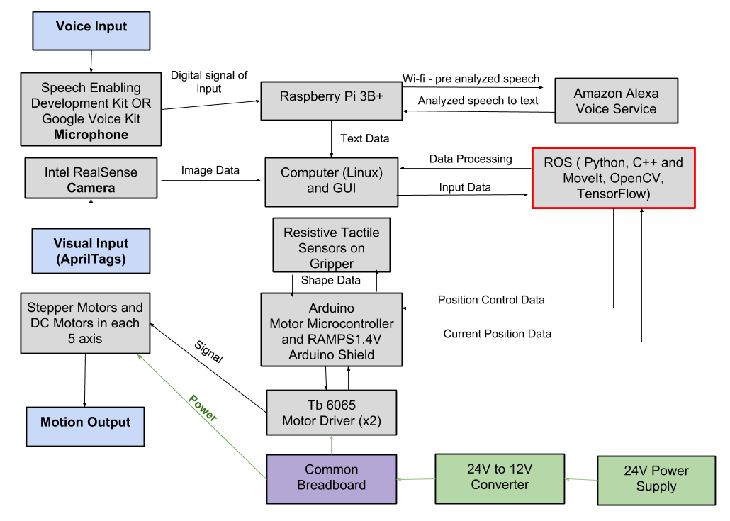

**Figure 3. Design diagram and interactions between parts of the project**

For the spring semester deliverables, at the recommendation from our academic advisor, we have decided to use a Google Aiy Voice Kit. Our main design constraint is the time allotted to develop a gripper that’s capable of grabbing a larger range of objects. The Intel Realsense camera does not process images one foot within the origin point therefore we need to consider Knuckles to be able to move away at least a foot to be able to scan the entire workspace.

**Schedule**

**Table 1. Team deadlines and milestones**

|  |  |  |  |  |  |
| --- | --- | --- | --- | --- | --- |
| **Date** | **Entire Group** | **Rym** | **Andrew** | **Matthew** | **Paola** |
| **November 20th (Milestone 2)** | **Simulate the arm design in RViz. Arm has all hardware attachments.**  **Camera works and provides locations**  **Get response from tactile pads.** |  |  |  |  |
| **November 21 - 25** | ***Thanksgiving holiday*** | ***Buffer*** | | | |
| **November 27th** | ***Facilitator meetings*** | ***Buffer*** | | | |
| **November 30th** |  | **Arm properly responds to text commands** | | **Physical arm fully follows simulation seen in RViz** | |
| **December 1 - 12** | ***Final exams, no classes*** | ***Buffer*** | | | |
| **December 7th** |  | **Manual control of robotic arm using a controller** | |  |  |
| **December 14th** | **Microphone can take audio input and convert to text for voice commands** |  |  |  | ***Buffer*** |
| **December 21st** | **Arm can remember path made when controlled and duplicate the motion when given the text/voice command** |  | ***Buffer*** |  |  |
| **January 4th** | **Switch from April tags to real time object recognition. Arm can create 3D map of its environment** |  |  |  |  |
| **January 11th** | **Arm can properly locate requested object (via voice command), pick it up and present requested object to user** | **Redesign base of arm to consolidate and accommodate microphone** | |  |  |
| **January 14th** | ***First day of spring semester*** | **Mount microphone on arm.** | |  |  |
| **January 18th** | **Arm can be given an object, and place that object in an empty spot on the table** |  |  |  |  |
| **January 20th (Milestone 3)** | **Implement 3D mapping using RealSense. Simulate object detection and implement on the physical robot. Robot will be able to locate and pick up objects in its environment** |  |  | **Fully trained object detection can recognize every object will most likely encounter. Responds to voice commands** | |
| **February 15th (Milestone 4)** | **Improved object recognition and user position recognition. Implement voice recognition software to accept voice commands** |  |  |  |  |
| **March 8th**  **(Milestone 6)** | **Implement final voice commands reference library. Robot arm needs to be 100% done!** | **Display arm at IEEE Chili Cook-Off** | | | |
| **March 11th - 17th** | ***Spring Break.* Prep Robot for travel** |  | ***Buffer*** |  |  |
| **March 26th**  **(ECEDHA)** | **Demonstrate arm at ECEDHA Conference** |  | **At Conference** |  |  |

**Budget**

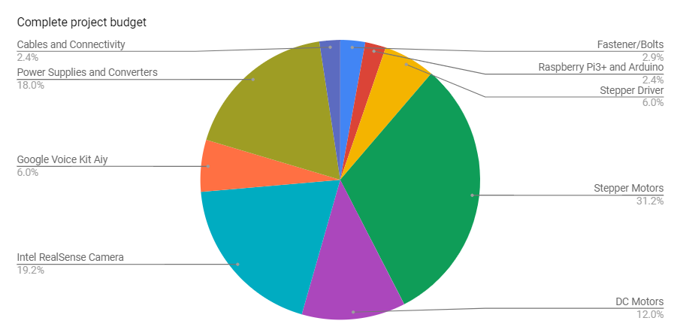

**Figure 4: Graphical representation of budget**

Our advisor, Dr. Becker, suggested us to change the original microphone that we had considered using, the Intel Speech Developer Kit, to the Google Voice Kit Aiy, which had a very similar functionally, plus we would save around $400. As in for the Stepper Motors, we made a mistake of purchasing the wrong size motor, and so we bought the right size motor with the money we saved from the microphone. Without of sponsors, we wouldn't have been able to obtain most part of our project.

**Project Summary**

To summarize, the physical robot arm is constructed and we are testing the motors motions. The user will be able to use a simulation in RViz to control the robot through text commands. By the end of the Spring semester, the object detection and voice recognition of the project will be completed, and the user will be able to give voice commands to request objects from Knuckles. We will accomplish our target objective by following a modular test plan, allowing us to develop the hardware and software in tandem. We are on track to complete our project by the end of the Spring semester.

1. Gross, Michael. “Chronic stress means we’re always on the hunt”. Current Bioligy, https://www.cell.com/current-biology/fulltext/S0960-9822(14)00489-8
2. Boblard, Lionell. “Injured Workers.” *SFM Mutual Insurance*, [www.sfmic.com/injured-workers/](http://www.sfmic.com/injured-workers/).